**Overview**

In this project, we will learn how to make our own **IoT Based Electricity Energy Meter** using **ESP32** & monitor data on the **Blynk Application**. Earlier we built **Home Automation Based on Blink Platform**

. With the current technology, you need to go to the **meter reading** room and take down readings. Thus monitoring and keeping track records of your **electricity consumption** is a tedious task. To automate this, we can use the Internet of Things. The Internet of Things saves time and money by automating **remote data collection**. Smart **Energy Meter** has received quite a lot of acclaim across the globe in recent years. So, why not to build our own **IoT Based Electricity Energy Meter**?

We need to select the **current sensor** as well as the **voltage sensor** so that the current & voltage can be measured and thus we can know about the power consumption & total power consumed. The best current sensor available in the market is SCT-013. This is **SCT-013 Non-Invasive AC Current Sensor** Split Core Type Clamp Meter Sensor which can be used to measure AC current up to **100 amperes**. Similarly, the best voltage sensor is the AC Voltage Sensor Module ZMPT101B. The **ZMPT101B AC Voltage Sensor** is the best where we need to measure the accurate AC voltage with a voltage transformer.

Using the **SCT-013 Current Sensor & ZMPT101B Voltage Sensor**, we can measure the all required parameters needed for Electricity Energy Meter. We will interface the SCT-013 Current Sensor & ZMPT101B Voltage Sensor with **ESP32 Wifi Module** & Send the data to Blynk Application. The **Blynk Application** Dashboard will display the *Voltage, Current, Power & total unit consumed in kWh*.

## ****SCT-013 Current Sensor****

[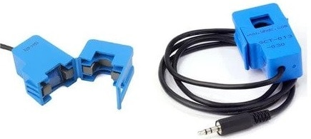](https://how2electronics.com/wp-content/uploads/2020/12/SCT-013-Current-Sensor.jpg)

The [**SCT-013**](https://www.mcielectronics.cl/website_MCI/static/documents/Datasheet_SCT013.pdf) is a Non-invasive AC Current Sensor Split Core Type Clamp Meter Sensor that can be used to measure **AC current** up to 100 amperes. Current transformers (CTs) are sensors are for measuring alternating current. They are particularly useful for measuring whole building electricity consumption. The SCT-013 current sensors can be clipped straight either to the **live** or **neutral wire** without having to do any high voltage electrical work.

[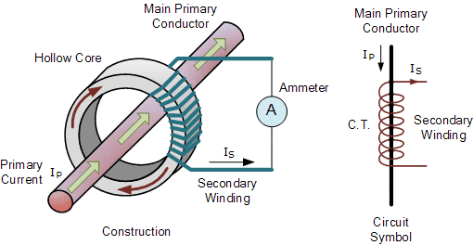](https://how2electronics.com/wp-content/uploads/2020/12/Current-transformer.gif)

Like any other transformer, a **current transformer** has a primary winding, a magnetic core, and a secondary winding. The secondary winding comprises many turns of fine wire housed within the casing of the transformer.

### ****Specifications****

1. Input Current: ***0-30A AC***2. Output Signal: ***DC 0-1 V***3. Non-linearity: ***2-3 %***4. Build-in sampling resistance (RL): ***62 Ω***5. Turn Ratio: ***1800:1***6. Resistance Grade: ***Grade B***7. Work Temperature: ***-25 °C~+70 °C***8. Dielectric Strength (between shell and output): ***1000 V AC / 1 min 5 mA***

## ****ZMPT101B AC Single Phase Voltage Sensor****

[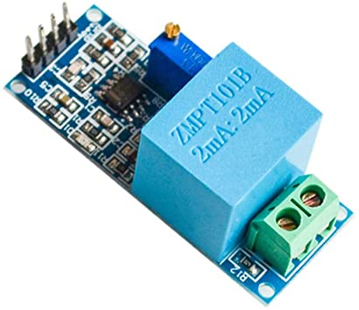](https://how2electronics.com/wp-content/uploads/2020/12/ZMPT101B.jpg)

The [**ZMPT101B**](http://5nrorwxhmqqijik.leadongcdn.com/attachment/kjilKBmoioSRqlkqjoipSR7ww7fgzb73m/ZMPT101B-specification.pdf) AC Single Phase voltage sensor module is based on a **high precision ZMPT101B voltage Transformer** used to measure the accurate AC voltage with a voltage transformer. This is an ideal choice to measure the AC voltage using Arduino or ESP32.

The Modules can measure voltage within **250V AC voltage** & the corresponding analog output can be adjusted. The module is simple to use and comes with a **multi-turn trim potentiometer** for adjusting and calibrating the ADC output.

### ****Specifications****

1. Voltage up to ***250 volts*** can be measured2. Lightweight with on-board micro-precision voltage transformer3. High precision on-board op-amp circuit4. Operating temperature : ***40ºC ~ + 70ºC***5. Supply voltage ***5 volts*** to 30 volts

## ****Circuit Diagram & Hardware Setup****

Now let us see the **circuit diagram** of IoT Based Electricity Energy Meter using ESP32. The circuit has been designed using Fritzing software.

[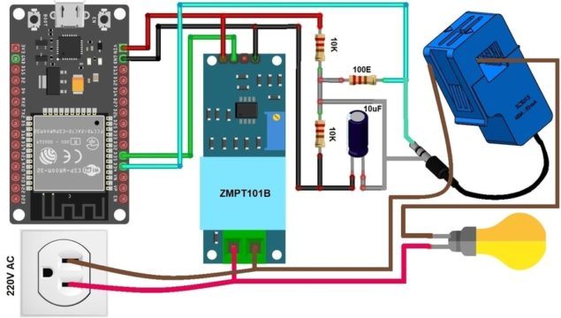](https://how2electronics.com/wp-content/uploads/2020/12/IoT-Based-Electricity-Energy-Meter.jpg)

The connection diagram is simple. Both the Sensor, i.e. SCT-013 Current Sensor & ZMPT101B Voltage Sensor VCC is connected to **Vin** of ESP32 which is a **5V Supply**. The GND pin of both the modules is connected to the **GND** of ESP32. The output analog pin of the ZMPT101B Voltage Sensor is connected to **GPIO35** of ESP32. Similarly, the output analog pin of SCT-013 Current Sensor is connected to **GPIO34** of ESP32. You need a two resistor of **10K** & a single resistor of **100 ohms** connected along with a **10uF** Capacitor.

## A fully integrated suite of IoT software

Everything you need to build and manage connected hardware: device provisioning, sensor data visualization, remote control with mobile and web applications, Over-The-Air firmware updates, secure cloud, data analytics, user and access management, alerts, automations and much much more…

Blynk platform powers low-batch manufacturers of smart home products, complex HVAC systems, agricultural equipment, and everyone in between. These companies build branded apps with no code and get the full back-end IoT infrastructure through one subscription.

### Blynk logoAdvantages of Smart Meters

Smart meters can **benefit the electric company** by...

* Eliminating manual meter reading
* Monitoring the electric system more quickly
* Making it possible to use power resources more efficiently
* Providing real-time data useful for balancing electric loads and reducing power outages (blackouts)
* Enabling dynamic pricing (raising or lowering the cost of electricity based on demand)
* Avoiding the capital expense of building new power plants
* Helping to optimize income with existing resources

After the electric company has fully installed its advanced metering infrastructure, smart meters can **benefit the electricity customer** by...

* Offering more detailed feedback on energy use
* Enabling them to adjust their habits to lower electric bills
* Reducing blackouts and system-wide electric failures

Smart meters can ultimately **benefit the environment** by...

* Preventing the need for new power plants that would produce pollution
* Curbing greenhouse gas emissions from existing power plants
* Reducing pollution from vehicles driven by meter readers

### Disadvantages of Smart Meters

All technology has its advantages and drawbacks; while smart meters have their benefits, they also present challenges to electric utilities and customers. The vast majority of these drawbacks, however, are short term. Once the system has been set up and training is complete, smart meters can be very helpful to both electricity providers and consumers.

Smart meters present these **challenges and costs to the electric company**...

* Transitioning to new technology and processes
* Managing public reaction and customer acceptance of the new meters
* Making a long-term financial commitment to the new metering technology and related software
* Managing and storing vast quantities of metering data
* Ensuring the security of metering data

Smart meters pose these **challenges to consumers**...

* Verifying that the new meter is accurate
* Protecting the privacy of their personal data
* Paying additional fees for the new meter

Other disadvantages include the reality that smart meters put human meter readers out of work; to date, hundreds of individuals have lost their jobs. In addition, while it was anticipated that that smart meters would save consumers money, consumers rarely check their complex meters and thus are unable to make energy consumption changes.

While smart meters certainly make the collection of information simpler and billing less complex and arduous, other advantages have yet to materialize.